# Generic

REPL

Read Evaluate Print Loop

### IDE

jupyter

spyder

VScode

visual studio

IDLE

pycharm

### Basics

class

### interpreters

Cpython

jython → JVM

### keywords

if elif else

for while

break continue pass

True False

### comments

# single line

docstrings multi line

## Data Types

int

float

str

bool

True

False

complex

imaginary

## Operators

### arth

+

-

/

*

% modulo (remainder)

=

// floor division

** power of

#### multiple assignment

x = y = z = 100

x , y , z = 100, 200, "john snow"

### relational

<

>

<=

>=

==

!=

### logical

and

or

not

### bitwise

&

|

<<

>>

~

^

### identity

is

is not

### membership

in

not in

## Functions

### general

print()

type()

id()

range()

### conversion

str()

int()

float()

list()

tuple()

set()

dict()

### sequence

sorted()

len()

min()

max()

sum()

## strings

### features:

text data

double quotes or single quotes

index

negative index

IndexError

slice

part (or whole)

no IndexError

step

| I | D | L | Y |
| --- | --- | --- | --- |
| 0 | 1 | 2 | 3 |
| -4 | -3 | -2 | -1 |

immutable

### string functions

capitalize() lower() upper() title()

count() index()

isnumeric() isalpha() isalnum()

isupper() islower()

split() splitlines()

### escape sequences

\n new line

\t

\b

\v

\\ \

\” “

### formats

r raw string

%()

.format()

f f-strings (recommended)

### doc-strings

""" """

''' '''

used as:

regular string

multi-line comment

documentation

## list

features:

any data

[ ]

index

negative index

IndexError

slice

part (or whole)

no IndexError

step

mutable

nesting

### list functions

count() index()

insert() append() extend()

remove() pop() clear()

sort() reverse()

copy()

## tuple

features:

any data

( )

index

negative index

IndexError

slice

part (or whole)

no IndexError

step

immutable

nesting

### tuple functions

count() index()

## set

only unique members

unordered

no index

mutable

members:

immutable

int, str, tuple

nesting

features:

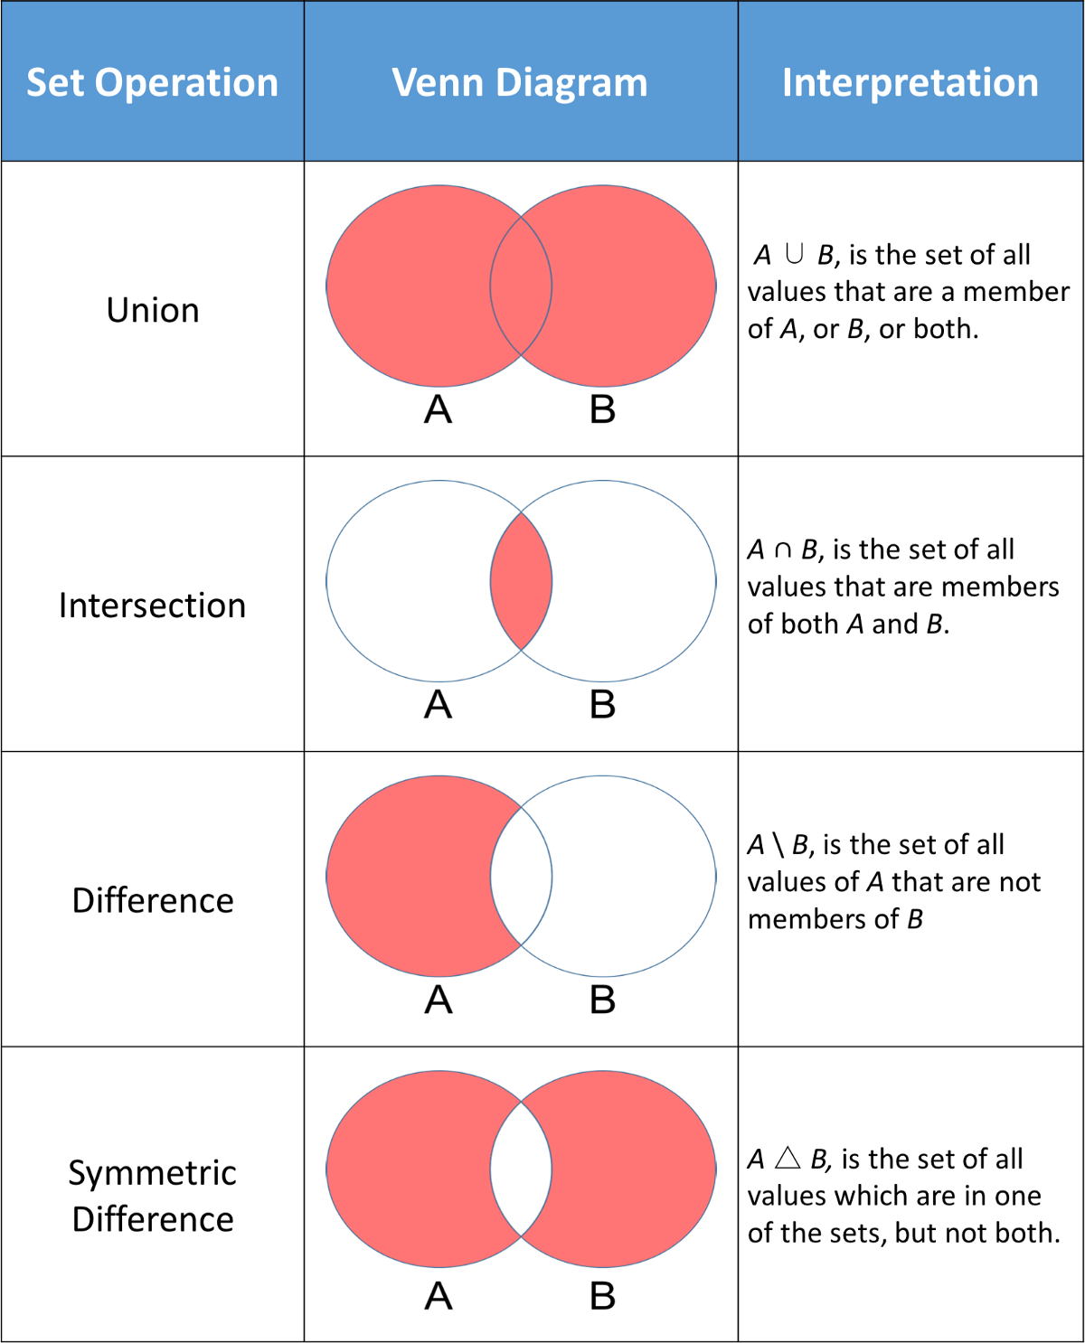

## dict

key:value

key:

index

unique

immutable

values:

anything (can be mutable)

mutable

## flow control

### if

if elif else

### false

0

0.0

'' ""

[ ]

{ }

False

None

### while

while else

break continue

### for

for in else

break continue

1. sequences
2. with range

## user defined functions

def global return

### return values

default is None

### arguments

any number, any data type

default arguments

variable number of arguments

arbitrary

args

kwargs

named arguments

## modules

### ways of import

1. import colour

colour.blue()

colour.yellow()

colour.green()

1. from colour import blue, yellow

blue()

yellow()

~~green()~~

1. from colour import *

blue()

yellow()

green()

1. import colour as c

c.blue()

c.yellow()

c.green()

1. from colour import blue as b

b()

extras:

command line args

exception handling

excel

graphs or plots (histogram)

linked list